Don’t Sink

Member

Alan Cai, Allen Zhang, Wenbo Wu, Yuying Chen, Yi Zhao

Abstract

In Don’t Sink, the player plays as a commander of a broken ship, and try to help the ship float for more time. You have some commendations to help drain the water out, but each commendation has advantages and disadvantages. While doing that you have to keep your eye on the resources you have, and balance the use of them to keep the ship afloat. The more time you keep the ship afloat the more passengers you will save.

Game Elements

**Water:** Core element in the game. The player has to prevent the ship from loading too much water. Once the water reaches the maximum number the game is over.

**The hole:** Ship will randomly break with holes, which will cause the water influent in. The player can try to drain out the water or choose to fix the hole.

**Worker:** Workers affect the efficiency of draining the water, also can fix the holes.

**Fire level:** The fire will disable part of the workers differently, depending on the level of the fire.

How to play

**Goal:** To keep the ship afloat as much time as you can by draining the water out.

**Controls:** There are several “holes” in the ship, which will randomly take in water. The player can press the related buttons repeatedly to drain out the water. Or the player can click the hole to plug it for a while. While the game is running there will also be random fire, which will influence the efficiency of the draining water and the player has to press space for seconds to put it out.

**Rules:** 1. After plugging the hole for some time, it will break again and double the taking in water amount.

2. The worker amount has an influence on draining efficiency.

3. Higher the fire level you have, the fewer workers you can use.

4. Game over when the water level reaches the maximum water capacity of the ship.

5. Time = people you save = scores!

Game Proposal

To make the system stocks have connections and feedback, we designed several elements and let them have negative or positive effects on each other. While the game is running, the player can easily find the relationship between the elements.

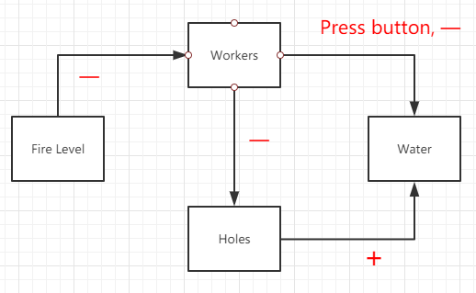

In the beginning, there will be only one or several holes in the ship. In this period the player can perform the draining and observe how the button influences the water. Then there will be more holes and the player need more reaction to take over all the holes. At that time, the player not only has to take care of the real-time strategy but also has to start thinking about the future strategy, that if he should plug the holes.

The real-time strategy together with the future strategy can change the rhythm of the whole game, to make the player not always busy but also not always free. But still, stuck in only several elements will make the game boring, so every few seconds there will be a variable to decide if there will be a fire on the ship. The random event will break the solid loop of the game, which also gives the player more constriction and make the game more challenge.

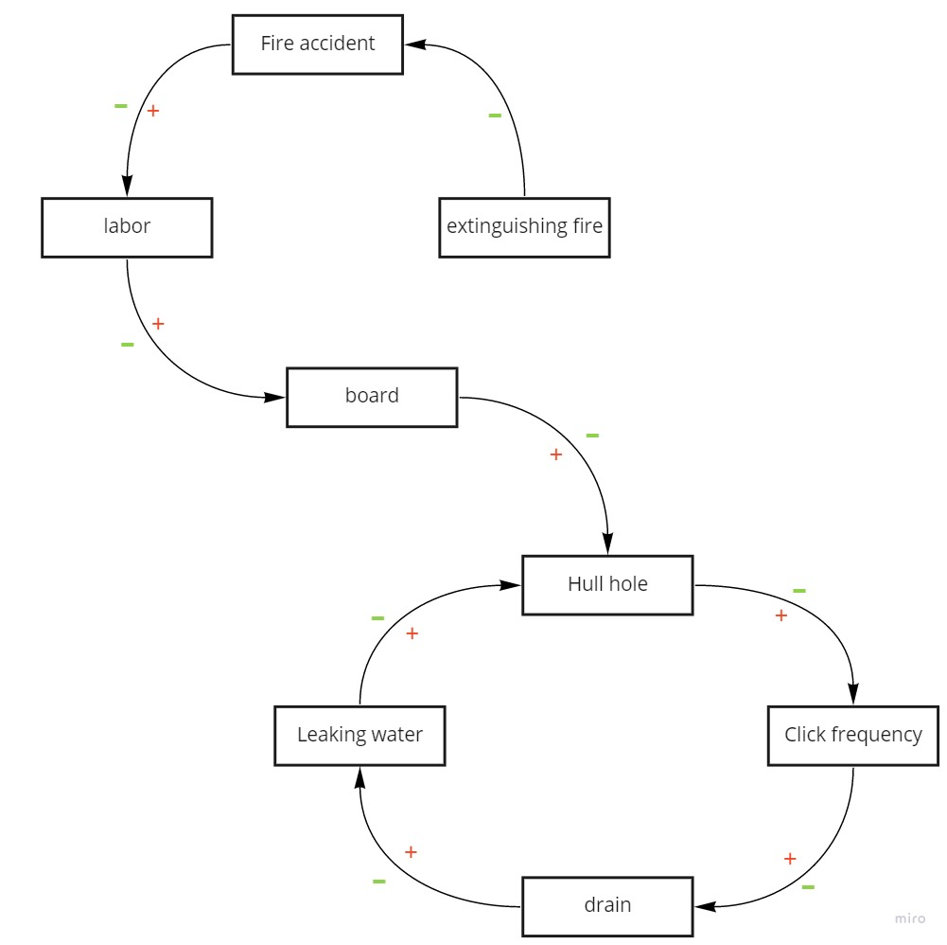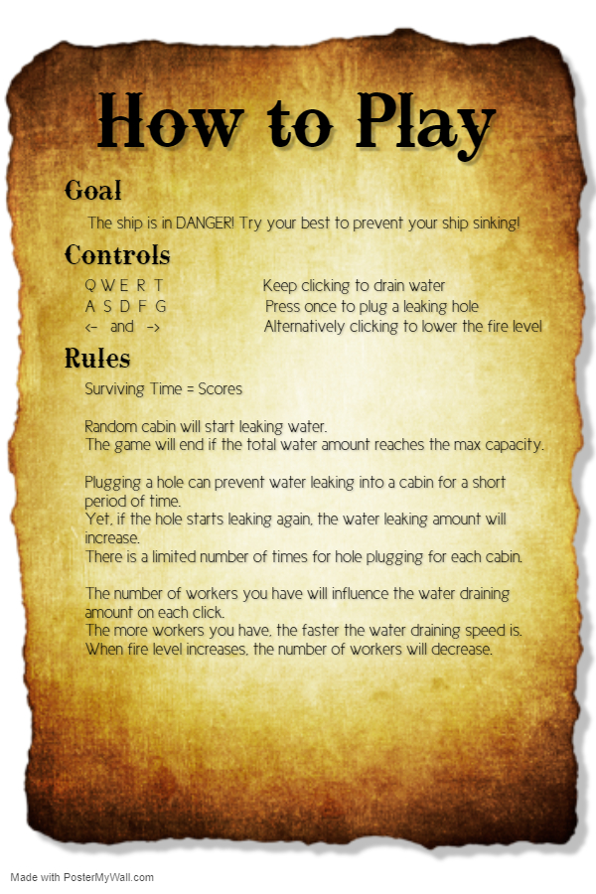

Playtest Feedback

1. Some players feel confused when they see the controls form, and find it hard to know how to use the keyboard to play. After the player try three times, they began to understand how to play the game.

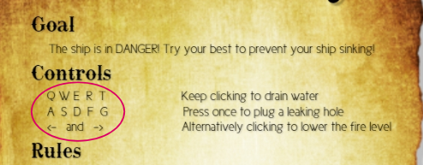

2. When the player sees the number on the pirate ship. The number may misleads the player, and some of them think that they should type the number for control. We can improve the UI display to guide the player better, so they can understand how to play this game.

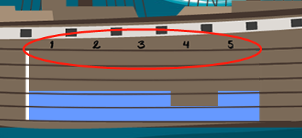

3. For the player who first played this game, they can't know how to plug the hole. They will notice this feature after we reminded them about it.

4. Some people think the game is too easy. Others believe it is a little complicated. So they suggest to make a choice that can change the game difficulty.

5. About the button to lower the fire level, some people consider that they type light and right button, no consequence, no other sophisticated operating.

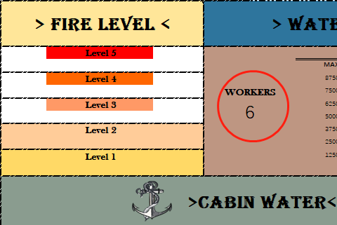

6. the player also doesn't know the meaning of workers. They only want to lower the fire level, so they keep type the light and right button. the players may ignore about the number of workers.

7. After clicking the start button, the player needs to click anywhere to start the game. To fix this problem, we can make a guideline to tell the player how to play the game

8. After game over, we also need to make a popup prompt to tell the player the game is finished, they can restart or end the game.